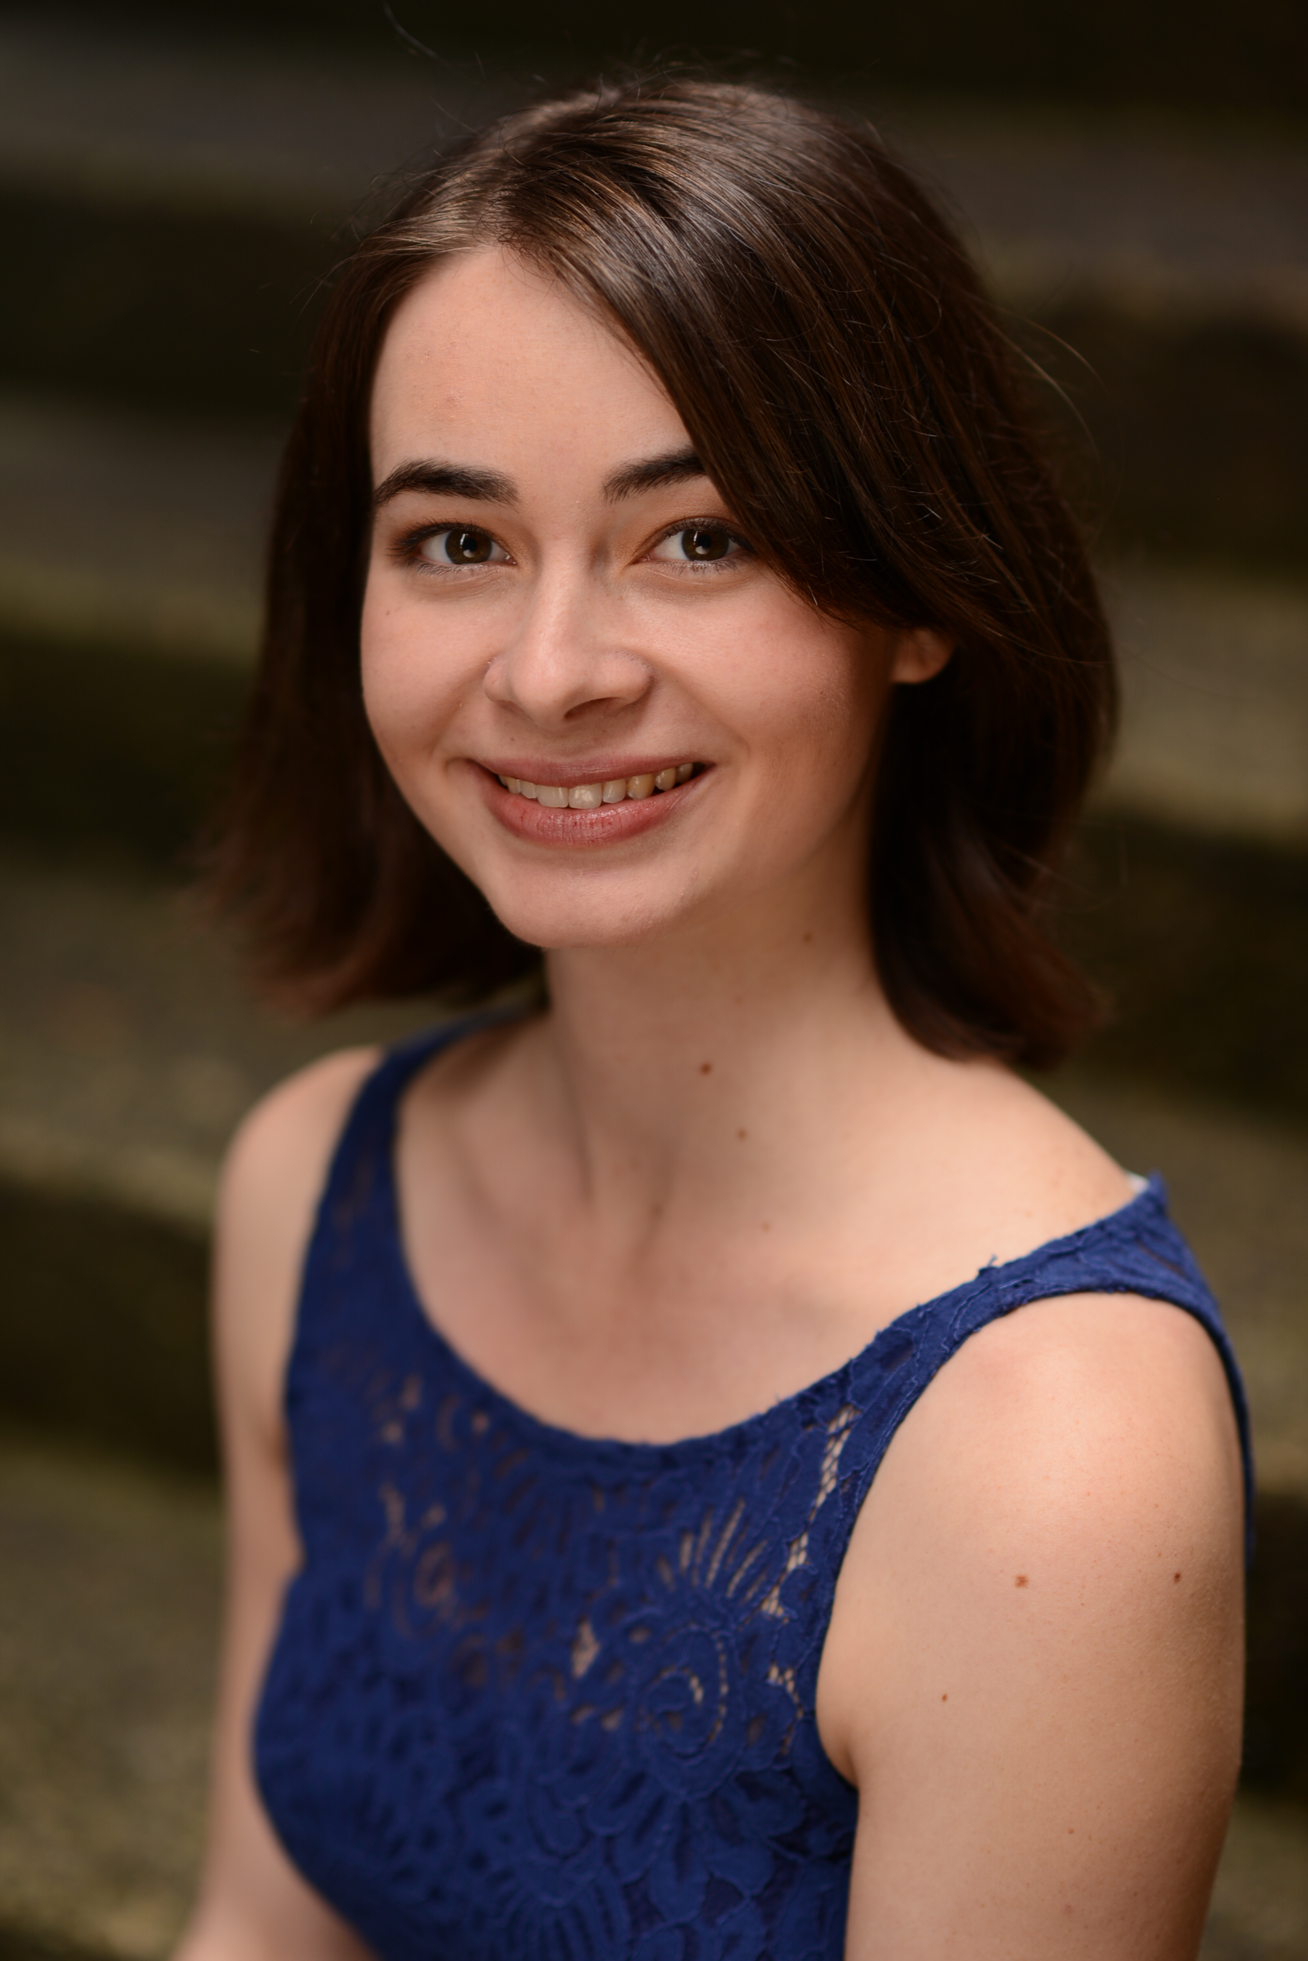
Laura Carskadden
Mezzo Soprano
Repertoire List

Opera

*Melissa | La liberazione di Ruggiero (Caccini) | Peabody Institute
*Rosette | Manon | Peabody Institute
*Carmen | Carmen | Peabody Institute
Mother | Earth to Kenzie (Pollock) | Peabody Institute
Juno | Orpheus in the Underworld | Utah Vocal Arts Academy
*Mistress Quickly | Falstaff | Utah Vocal Arts Academy
*Kate | Pirates of Penzance | Utah Vocal Arts Academy
*Third Spirit | Die Zauberflöte | Utah Vocal Arts Academy
 |  | Boston Conservatory in Valencia
*Idamante | Idomeneo | Utah Vocal Arts Academy
*Romeo | I Capuleti e i Montecchi | Peabody Institute
*Maddalena | Rigoletto | Peabody Institute
Prince Orlofsky | Die Fledermaus | Midwest Institute of Opera
 |  | High Point University
*Jo | Little Women | Boston Conservatory in Valencia
 |  | High Point University
Ma | The Tender Land | High Point University

*partial roles

Arias

Things Change, Jo | Little Women | Mark Adamo
Must the Winter Come So Soon | Vanessa | Samuel Barber
Deh! Tu bell’anima | I Capuleti e I Montecchi | Vincenzo Bellini
Che faró senza Euridice | Orfeo ed Eurydice | Christoph Willibald Gluck
Que fais-tu, blanche tourterelle? | Roméo et Juliette | Charles Gounod
Svegliatevi nel core | Giulio Ceasare | George Frideric Handel
Dopo notte | Ariodante | George Frideric Handel
Hurr Hopp Hopp Hopp | Hänsel und Gretel | Engelbert Humperdinck
Va! Laisse couler mes larmes | Werther | Jules Massenet
Che scompiglio, che flagello | La finta semplice | W. A. Mozart
Voi che sapete | Le nozze di Figaro | W. A. Mozart
Torna di Tito a lato | La clemenza di Tito | W. A. Mozart

Oratorio/Concert

Esurientes | Magnificat | J. S. Bach
Bereite dich Zion | Christmas Oratorio | J. S. Bach
A New Creation |  | René Clausen
The Swimmer | Sea Pictures | Edward Elgar
But who may abide | Messiah | George Frideric Handel
He shall feed his flock | Messiah | George Frideric Handel

English Art Song

The Daises |  | Samuel Barber
Amor |  | William Bolcom
Weep you no more, sad fountains |  | John Dowland
Loveliest of Trees |  | John Duke
The Silver Swan |  | Orlando Gibbons
Songs for the People |  | Rosephanye Powell
I Want to Die While You Love Me |  | Rosephanye Powell
A Winter Twilight |  | Rosephanye Powell
Nymphs and Shepherds |  | Henry Purcell
If music be the food of love |  | Henry Purcell
The Sky Above the Roof |  | Ralph Vaughan Williams
Silent Noon |  | Ralph Vaughan Williams

German Art Song

Ach, wende diesen Blick |  | Johannes Brahms
Immer leiser wird mein Schlummer |  | Johannes Brahms
Liebestreu |  | Johannes Brahms
O kühler Wald |  | Johannes Brahms
Laue Sommernacht |  | Alma Mahler
Der Blumenstrauss |  | Felix Mendelssohn
Als Luise de Briefe |  | W. A. Mozart
Am See |  | Franz Schubert
Liebst du um Schönheit |  | Clara Schumann
Du bist wie eine Blume |  | Robert Schumann

French Art Song

Ouvre ton cœur |  | Georges Bizet
Chanson triste |  | Henri Duparc
Clair de lune |  | Gabriel Fauré
Mandoline |  | Gabriel Fauré
A Chloris |  | Reynaldo Hahn
L’heure exquise |  | Reynaldo Hahn

Italian Art Song

Sebben crudele |  | Antonio Caldara
Intorno all’idol mio |  | Antonio Cesti
Se a te d’intorno scherza |  | Gaetano Donizetti
Sento nel core |  | Alessandro Scarlatti
Cara e dolce |  | Alessandro Scarlatti
La serenata |  | Paolo Tosti
La seduzione |  | Giuseppe Verdi

Spanish Art Song

Asturiana |  | Manuel de Falla
El paño moruno |  | Manuel de Falla

